Visualizing and Understanding Optimization Problems
Using Dynamic Software

One of the guiding principles of the calculus reform movement over the past quarter century has been the notion of approaching every concept and technique from graphical and numerical as well as symbolic points of view. Some have re-interpreted this principle by adding that one should also approach every topic verbally and/or dynamically as well. In large measure, the impetus for emphasizing the graphical approach is based on the very strong case made by (Zimmerman and Cunningham, 1991) for the need to stress visualization in order for students to gain a solid understanding of the concepts and methods in all areas of mathematics. This theme was reinforced by all the included articles in the volume that cover the entire undergraduate mathematics curriculum, with special attention on calculus. In turn, this became the dominant theme in the calculus reform movement, as many mathematics educators accepted this principle or as many more came to the same conclusion from other perspectives. (See, for example, (Hughes-Hallett, Gleason, et al., 1994), (Smith and Moore, 1996), and (Dick and Patten, 1994).) In particular, (Hughes-Hallett, Gleason, et al., 1994) enunciated the so-called Rule of Three, stating that every topic and technique in calculus should be approached analytically, graphically, and numerically.
However, the implementation of this principle invariably hits a brick wall when first year calculus courses reach certain topics and sets of problems that seemingly involve traditional symbolic manipulation and rote learning exclusively. Two such are techniques of integration and l’Hopital’s Rule; the present author has previously discussed approaching both from the perspective of using dynamic software to increase student understanding of the underlying ideas and their applications in (Gordon, 2017) and (Gordon, 2016a).
Another such topic in introductory calculus where the standard presentation all-too-often becomes bogged down in heavy algebra so that it reduces to mere symbolic manipulation is with optimization problems, where the presentation typically devolves into a great many problems that are primarily symbolic manipulation exercises with little emphasis on conceptual understanding. In this article, we look at several of the standard optimization problems usually encountered in introductory calculus and which can be well served by introducing graphical, numerical, and dynamic perspectives that provide different and in some ways deeper insights into the methods and concepts.
Some related discussions are in (Hong and Lee, 2013), who consider a few specific examples of standard optimization problems from the perspective of using GeoGebra. They also include an extensive collection of references of general discussions of using dynamic software, primarily GeoGebra, for teaching and learning mathematics. (Ochkov and Bogomolova, 2015) likewise provide some solid overviews of the rationales for using dynamic software to improve the teaching and learning of undergraduate mathematics. (Hohenwarter and Preiner, 2007) give an extensive overview of the capabilities of GeoGebra and (Hohenwarter, et al., 2008) demonstrate a variety of calculus-based modules in GeoGebra. The website (GeoGebra Simulations, 2019) provides a variety of optimization simulations for calculus and other areas of mathematics.
However, there seem to be surprisingly few published articles discussing the use of dynamic software to help students understand and therefore master the techniques involved in optimization problems. Despite this, there are a tremendous number of internet postings regarding individual problems. For instance, a google search for “calculus, farmer problem” resulted in 49,500,000 hits! A similar search with “farmer fencing problem” had 24,700,000 hits. The overwhelming preponderance of those the author looked at show detailed solutions to individual statements of the problem with varying numbers. A reasonable number of them are YouTube videos displaying how the analytic solution is obtained. A few contain what the posters call calculators, which are Apps where the student enters the values for the parameters associated with a problem and the App spits out the answer. In all likelihood, it is fairly certain that, within that huge number of postings, there will be dynamic simulations showing the situation as a sketch, along with some kinds of dynamic display, but the author has not come across any.

Background The current author’s experience is that most of the critical topics in calculus can be dramatically presented using either graphing calculators or computer graphics software to allow students to visualize the underlying concepts and so enhance their understanding of the associated methods and their applications. Many years ago, the author addressed the challenge of making these notions evident to students by developing a comprehensive package of computer graphics programs using BASIC that addressed virtually every topic in introductory calculus. BASIC routines have become outmoded over the years. While many of these concepts and methods can be displayed on a graphing calculator, it is often too slow to provide essentially instantaneous displays as parameters change, which is a drawback when displaying the ideas and techniques in front of a class. Moreover, there are things that, unfortunately, cannot be well displayed on a calculator screen.
The author has lately returned to this challenge and has developed a much more extensive package of dynamic interactive graphical displays of the mathematics (DIGMath) using Excel because it is available on almost all computers today. In the U.S., Microsoft has seemingly made arrangements with almost all colleges and universities to provide students with the most current versions of Office for free. Moreover, Excel has the further advantages that it does not require any plug-ins or internet connections, as for example, using Flash, Java, or JavaScript, and it is the standard technology tool for virtually every quantitative discipline other than mathematics. (The complete package of over 100 programs for calculus can be obtained gratis from the author for instructors to use for in-class demonstrations of these ideas or for students to use for individual or small-group investigations and/or projects.)
Over the years, many other mathematics educators have thought deeply about these issues and have developed specialized software tools to implement dynamic displays of many of the basic calculus ideas and techniques using a variety of different platforms .
All of these efforts to bring technology to bear to improve students understanding of the concepts and methods of calculus have had considerable impact on the teaching of calculus, though by no means can one say that they have been universally accepted, let alone implemented. In part, this may be due to the fact that many mathematics faculty are still uncomfortable with using technology in the classroom or feel that it takes too much time to implement; some feel it is not appropriate to require students to purchase specialized software in addition to an expensive textbook and calculator; still others feel that the one software tool that almost all of their students will someday use in other courses and on the job is Excel (and the majority of students today arrive on campus today already knowing how to use it, having been using it routinely as early as grade 7 in the U.S.). Furthermore, most quantitatively-oriented people today are familiar with Excel and many are able to modify or create their own spreadsheets without having to learn a new computer language. As such, existing Excel spreadsheets provide templates that can be adapted to create comparable modules for other situations or to provide additional information and insights. As a consequence, there seem to be good reasons to have such dynamic programs available in Excel, so that both faculty and students can have easy access to their use without needing to expend money or time in learning/teaching new programs.
As part of the author’s package of Excel programs for calculus, he has developed a collection of dynamic modules that are intended to enhance student understanding of the fundamental concepts and procedures related to a wide range of standard optimization problems. As will be illustrated later in the article, these spreadsheets all use sliders (a feature to input or change values by moving, using a mouse, say, a square in a horizontal bar) and other Excel controls to provide dynamic effects in which parameters and associated values can be changed and the resulting effects can be seen both graphically and numerically virtually instantaneously. For those readers who might be interested in modifying these spreadsheets or creating new ones in Excel, instructions on implementing the Excel controls are presented in (Gordon, 2016b).
We note that because all of these spreadsheets use macros and the Excel controls, they unfortunately will not function properly in some of the free alternatives to the Microsoft products, such as OpenOffice, LibreOffice, and GoogleSheets, since each implements macros and controls in different ways to avoid potential copyright violations.
In this article, we will discuss the various aspects of setting up and solving optimization problems that can be enhanced using such software. We also hope to encourage others to think about developing comparable tools both for optimization situations and for all other topics in calculus and other mathematics courses.

Some Optimization Problems
The standard strategy given to students for solving optimization problems is:
1. Whenever appropriate, draw a rough sketch of the situation.
2. Create an expression for the function to be optimized.
3. Locate each of the critical points – all points where the derivative is zero or undefined and the endpoints of the interval for the domain.
4. Test each of these points using the first or second derivative test to determine which are relative maxima, relative minima, or neither.
5. Decide which of the points is an absolute maximum and which is an absolute minimum.
While the overall list of steps seems to suggest a focus on the underlying concepts, in practice the preponderance of the work ends up manipulative in nature – finding the first and second derivatives, solving for real roots, and evaluating those derivatives and the function itself at the critical points. For too many students, the underlying ideas quickly become lost in the process of performing the algebra and many resort to trying to memorize the steps associated with particular problems in the hope that they can regurgitate those steps on an exam where only the numbers have changed. Unfortunately, students who resort to this approach rarely can apply the optimization techniques to situations in subsequent courses, either in mathematics or in other disciplines. Moreover, any algebraic or arithmetic mistakes, however minimal, likely screw up the entire process.
1. Two Numbers with the Maximal Product We begin by looking at what is usually one of the first optimization examples presented in virtually every calculus textbook, that of finding two positive numbers x and y having a given sum S that have the greatest possible product P. While this is one of the simplest optimization problems, it does not admit of a rough sketch, so the above strategy does not automatically apply.
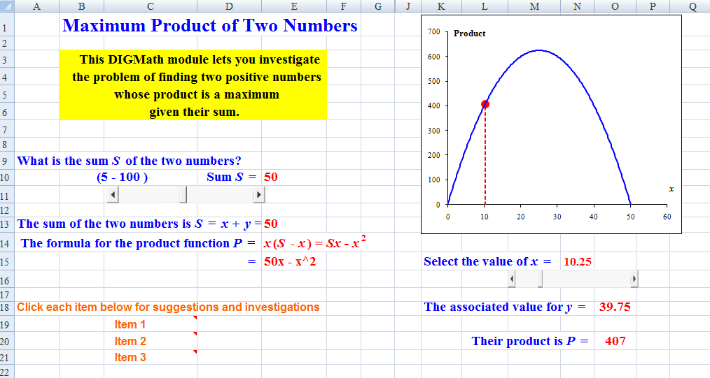 Figure 1 shows the screen from the dynamic spreadsheet that allows students to investigate this problem visually.
Figure 1: Finding Two Numbers with the Maximum Product

The slider on the left allows the user to select a value for the sum Sof the two numbers between S = 5 and S = 100. Below the slider, the spreadsheet displays the mechanics of setting up the formula for the product P, which is to be maximized. The graph to the right shows the associated curve, which has the shape that one should expect (a parabola opening downward) from its equation. The vertical line and the point on the curve represent the result of tracing along the curve, which is accomplished with the slider to the right that controls the horizontal distance x. As the point traces along the curve, the associated value for y is also displayed, as is the value for the product P. The lower graph shows the graph of the derivative, dP/dx, with the equivalent tracing point displayed. It is not surprising to note that the graph of the derivative function is seemingly linear with negative slope, which confirms the fact that the original curve appears to be a parabola that is concave down.
From these displays, it becomes very clear to students that they are seeking the point where the curve achieves its maximum value, which is equivalent to the point on the derivative graph where the derivative curve crosses the horizontal axis. It is also clear that, when x is far from that maximum point, the value for the product changes considerably as x changes slightly. However, when x is close to the turning point, the change in the value of the product is quite small, so that it becomes more difficult to pick out the optimal point by graphical trial-and-error.
What’s particularly effective with using a tool such as this is that one can trivially change the value for the sum S using the first slider and see immediately how things change.
We note that this, all the other spreadsheets, as well as all include a number of suggestions for further investigations and sometimes deeper notes about the mathematics. Each of these items appears when you click on the associated Item cell with the small arrowhead in the upper right corner. The spreadsheet for this problem also has a separate sheet (or page) at the bottom, which is not shown in Figure 1, that allows the user to conduct a comparable investigation of the related problem in which one seeks two positive numbers having a given product whose sum is minimal. A similar spreadsheet allows the user to investigate the comparable problem of optimizing the sum of the squares of two numbers.
As mentioned earlier, many others have developed a broad variety of web-based modules to address this problem, as well as almost every other common optimization problem. A Google search for “optimization, calculus, Numbers with maximum product” conducted at the time of writing returned 2,340,000 hits. Most of these are either compilations of many different optimization problems including the one just discussed or present detailed manipulative solutions of the problems; many are videos presenting the solution. However, a reasonable number do provide a variety of software tools for investigating the problem and its solution. This is typical of comparable searches for any of the other common optimization problems.
2. As our next example, we consider the hoary fencing problem in which Farmer Brown is planning to fence off a rectangular pen using a given length L of fencing (as well as some of the standard variations on the basic problem). In Figure 2, we show the associated display from the spreadsheet. Notice that it provides a sketch of the situation to help students visualize what is happening. The spreadsheet also allows the students to investigate the problem with their choice (200 – 1000 feet) for the perimeter L of the rectangular pen using the slider on the left and then displays the formula for the perimeter of the pen and the corresponding formula for the area of that pen. The upper graph on the right shows the area function A(x) as a function of the horizontal dimension x and the lower graph shows the derivative function A’(x). The slider at the lower right allows the user to trace a point simultaneously along both curves, so that the students see that they are looking for the maximum height of the area function, which corresponds to the point where the slope of the tangent line is zero and hence where the derivative function has a real root. The spreadsheet also displays the chosen value for x, the corresponding value for the height y, the corresponding area A(x), and the value of the derivative at that point.

Figure 2: 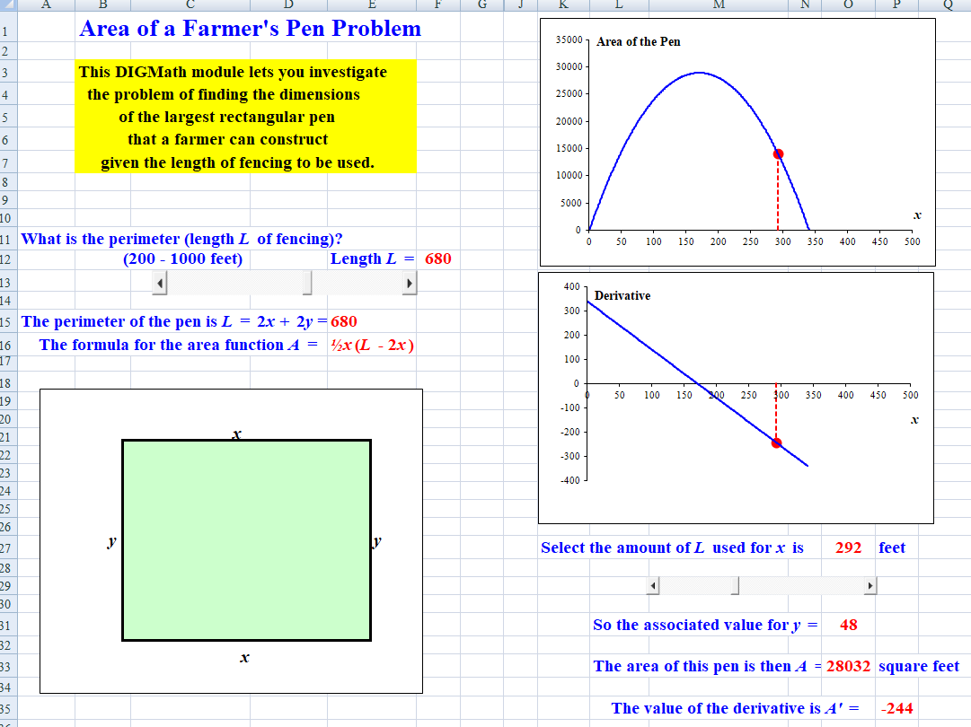The Spreadsheet Display for the Fencing Problem

In the process of using the spreadsheet, the students can see how the value for the area depends on the length of x, and how changes in x are reflected in the corresponding changes in the area. Thus, for points relatively near the local maximum, a given change in x has little effect on the change in y, because the slope is small there and so the rate of change is likewise small. However, for points relatively far from that maximum point, a given change in x produces a considerably larger effect on y because the slope is relatively large and so the rate of change is likewise large. The students also can see that the area function is seemingly quadratic with a negative leading coefficient, so its graph is a downward-opening parabola; the derivative is therefore a linear function, which is clearly seen from the graph of the derivative function.
Finally, we note that the spreadsheet provides on different pages the comparable features for visualizing the associated fencing problems where the rectangular pen is built along an existing wall (or stream), where there are two side-by-side pens, and where there are three side-by-side pens.

3. The Wire Cut to Form a Circle and a Square Problem Another standard optimization problem is the one where a length L of wire (or cord or string) is cut into two pieces, one of which is used for form a circle and the other to form a square. The problem is to determine how to cut the wire so that the sum of the areas of the two components is either maximal or minimal. Figure 3 shows the display from the author’s spreadsheet for investigating this problem.

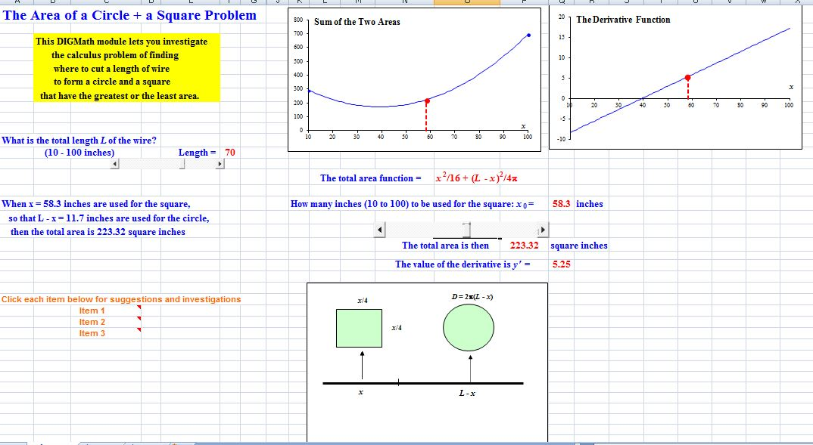Figure 3: The Wire into a Circle Plus a Square Problem

Notice that the spreadsheet includes a sketch of the situation to help students visualize what is happening. It allows the students to investigate the problem with their choice (10 – 100 inches) for the length L of the wire using the slider on the left. A second slider allows the students to select the number x of inches that will be used to form the square (whose sides are therefore each x/4) and then gives the length of wire used to form the circle and the total area of the circle. The spreadsheet also displays the formula for the total area of the two shapes as well as the area A(x) encompassed by the two pieces of wire as a function as a function of the perimeter of the square. It also displays the value of the derivative A’ corresponding to the perimeter x of the square.
The upper graph on the left shows the area function A(x) as a function of x and the graph of the right shows the derivative function A’(x). The slider allows the user to trace the points corresponding to x along both curves, so that the students see that the absolute maximum for the sum of the two areas occurs at the right endpoint where all of the wire is used to form the square and the radius of the circle is therefore 0. If the total length of wire is L = 70, then this maximum total area is roughly 696.2 square inches. The minimum total area corresponds to the point where the derivative function has a real root and this occurs roughly at x = 40 inches, so the sides of the square are about 10 inches each. This minimum total area is roughly 171.5 square inches. The fact that these conclusions are only estimates is actually helpful in the sense that students see that they still need to go through the formal algebraic analysis to get exact answers.

4. The Maximum Viewing Angle Problem We now consider the problem of finding the distance one should stand or sit from a painting on the wall or a movie screen in order to maximize the viewing angle α. The associated spreadsheet display is shown in Figure 4. This spreadsheet allows the students to investigate the problem with their choice (1 – 10 feet) for the height H of the bottom of the painting or screen above eye level using the upper slider on the left. A second slider allows the students to select the height T (1 – 6 feet) of the painting. Based on the choices for these two values, the spreadsheet also displays the formula for the viewing angle α; for instance, if H = 5 and T = 2, then the corresponding function is
α = Arctan (7/x) – Arctan (2/x),
where x is the distance from the wall. The form of this expression makes this one of the most algebraically complicated optimization problems in introductory and hence one of the most challenging for students both in terms of the set-up and the algebraic manipulations.

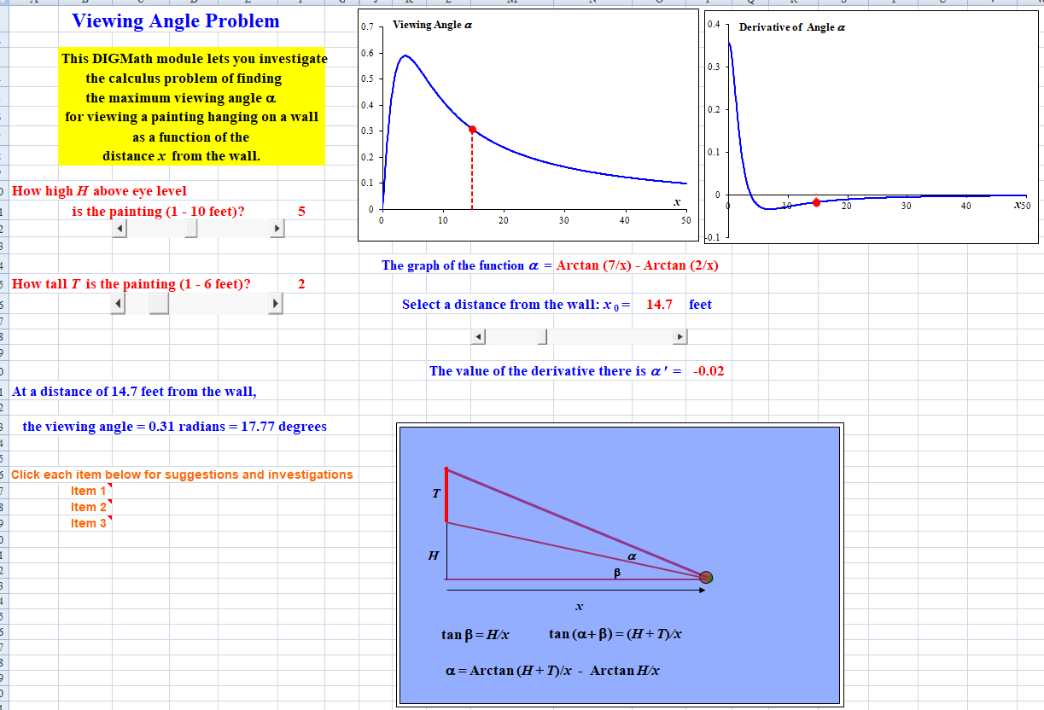Figure 4: The Maximum Viewing Angle Problem

The spreadsheet also shows the graph of the viewing angle α as a function of x, as well as the graph of the derivative of α with respect to x. At a distance of 0 feet from the wall, the viewing angle is 0 and α grows quite rapidly to a maximum value of approximately 0.59 radians ≈ 33.73° at a distance of 3.9 feet from the wall, based on H = 5 and T = 2. Thereafter, as x increases, the viewing angle slowly decays and, in fact, eventually approaches 0 as x → ∞. The values for the derivative α’ drop very rapidly as x increases away from 0, eventually becoming negative and then slowly rising toward the horizontal axis as a horizontal asymptote. As with the previous, example, however, it is necessary to utilize the algebraic analysis to get the precise location of the turning point.

5. The Distance of a Point to a Parabola Problem Our last example is one of the geometry-based optimization problems –that of finding the point P(a, b) that is closest to the parabola y = x². The associated spreadsheet display is shown in Figure 5. Students can enter the values for the coordinates a and b of the point P using a pair of sliders. The spreadsheet includes a dynamic display of the parabola, the point P, and the tracing point along the parabola. It also displays the graph of the distance function, which is
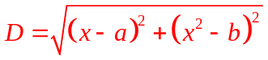

and the graph of the associated derivative function D’(x), where x is the tracing point along the parabola. The spreadsheet also shows the distance D from P to the point on the parabola and the corresponding value of the derivative.
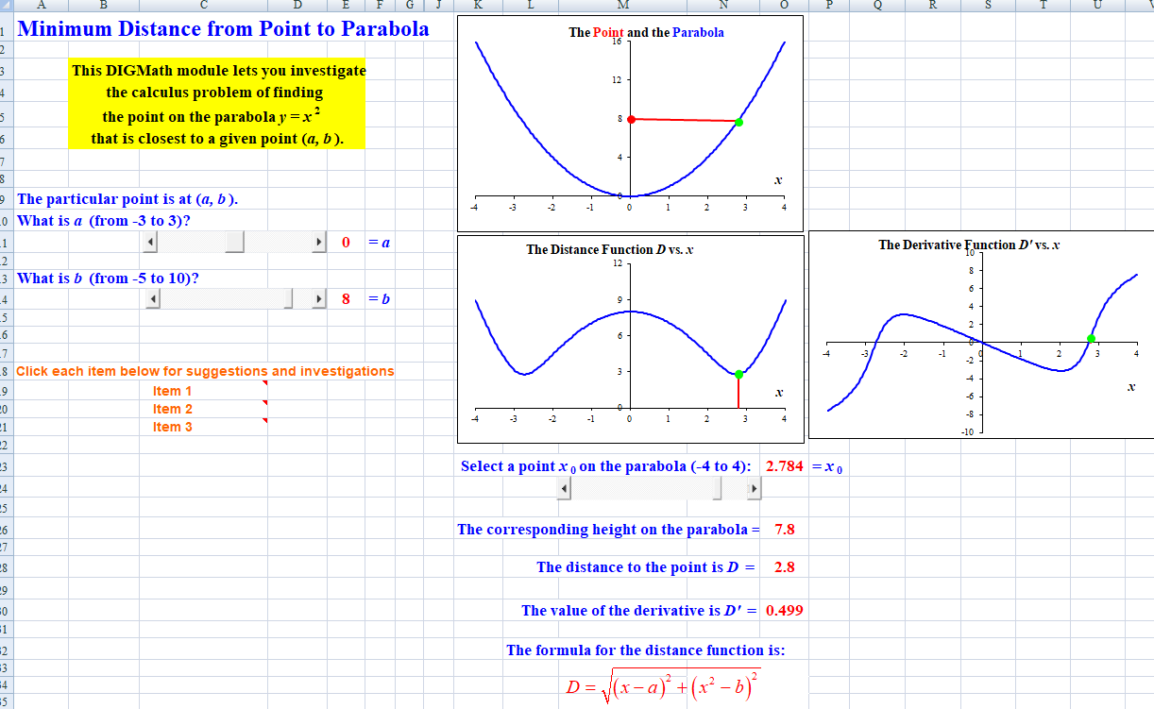“”Figure 5: The Point Closest to a Parabola Problem

Unlike the previous examples, this function has three distinct turning points and hence the derivative function has three distinct real roots. It cannot have any additional turning points because, clearly, the distance function eventually increases monotonically as x gets larger in either the positive or negative direction. One of the turning points is at x = 0, which corresponds to the vertex of the parabola. The other two turning points are located symmetrically at x ≈ ±2.72. In order to get the exact values, one must again resort to the algebraic analysis.

At this point in time, the author has completed dynamic Excel spreadsheets to allow students to investigate many other standard optimization problems, including the following:
The Largest Rectangle that Fits in a Circle Problem.
The Ladder Around a Corner Problem.
The Printed Page Problem.
The Norman Window Problem.
The Open Box Problem.
The Cost of a Tin Can Problem.
The Cylinder Inscribed in a Cone Problem.
Additional spreadsheets will likely be developed and posted over time.
Incidentally, the author is definitely not suggesting that every optimization problem should be presented, especially in class, in conjunction with such a dynamic investigation, even if comparable spreadsheets were available for all of them. There is never enough class time available and, to be honest, the undue repetition would cause all students to tune out. Rather, he recommends that perhaps three would be a more ideal number to do – the repetition would be instructive in reinforcing the key ideas, since many students do not internalize the concepts with just a single example. Instructors are also encouraged to distribute the spreadsheets to their students, so that they can utilize them on their own to investigate additional optimization situations on their own if they need more repetition.

Summary
If instructors do not emphasize the conceptual understanding behind techniques such as solving optimization problems, many students (particularly those with relatively weak mathematical backgrounds) will likely not develop that understanding on their own, but will rather merely apply computational methods by rote. They will almost certainly carry little of value on to subsequent math courses or to courses in other fields.
Dynamic software that brings the concepts to life with visual images can go a long way toward significantly enhancing student understanding of the fundamental ideas and techniques of calculus and, in turn, may help in keeping those ideas alive after the course is over. Although virtually every topic in freshman calculus can be explored in this way, the present article has only focused on optimization problems, which is one of the more basic applications in the first course in calculus and which often is one of the more technically challenging topics in that course.

References
Dick, Thomas P. and Charles M. Patton, (1994), Calculus of a Single Variable, PWS Publ., Boston, MA.
GeoGebra Simulations, (May, 2019), Optimization Simulations using GeoGebra,
URL: https://math.libretexts.org/Visualizations_and_Simulations/GeoGebra_Simulations
Gordon, Sheldon P, (July 2020), Dynamic Investigatory Graphics for Mathematics (DIGMath) Spreadsheets for Calculus, Farmingdale State College of SUNY, URL: https://www.farmingdale.edu/faculty/sheldon-gordon.shtml
Gordon, Sheldon P, (2017), Visualizing and Understanding l’Hopital’s Rule, Int’l J of Math Education in Science & Tech, 48.
Gordon, Sheldon P, (2016a), Visualizing Techniques of Integration, Mathematics and Computer Education, 47.
Gordon, Sheldon P, (2016b), Taking Control of Excel, Math and Computer Education, 47.
Hohenwarter, Markus and Judith Preiner (2007), GeoGebra, J. of Online Mathematics and its Applications, 7.
Hohenwarter, Markus, Judith Hohenwarter, et. al., (2008), Teaching and learning calculus with free dynamic mathematics software GeoGebra, ICME 11, Monterrey, Mexico.
Hong, Dae S. and Jae Ki Lee, (2013), Synthesising Algebraic and Graphical Represen-tations of the Maximum and Minimum Problems, Int’l J of Tech in Math Ed, 20.
Hughes-Hallett, Deborah, Andrew Gleason, et al., (1994), Calculus, 1st Ed., John Wiley & Sons, NY.
Ochkov, Valery F. and Elena P. Bogomolova, (2015), Teaching Mathematics with Mathematical Software, J. of Humkanistic Mathematics, 5.
Smith, David A. and L. C. Moore, (1996), Calculus: Modeling and Application, Houghton Mifflin Co., NY.
Zimmerman, Walter and Stephen Cunningham, (1991), Visualization in Teaching and Learning Mathematics, MAA Notes #19, Mathematical Association of America, Washington, DC.

